Experiment No – 6

Aim : To implement Mobile node discovery in J2ME

Code:

Midlet.java

import javax.microedition.lcdui.\*;

import javax.microedition.midlet.\*;

public class Midlet extends MIDlet implements CommandListener{

private Display display;private Form form;private Form outForm;

private StringItem outGreet;private TextField txtname,txtpassword;

private Command login = new Command(&quot;Login&quot;, Command.OK, 2);

public Midlet() {

display = Display.getDisplay(this);

form = new Form(&quot;Login&quot;);

txtname = new TextField(&quot;User id:&quot;,&quot;&quot;,250,TextField.ANY);

txtpassword = new TextField(&quot;Password:&quot;,&quot;&quot;,250,TextField.PASSWORD);

form.append(txtname); form.append(txtpassword);

form.addCommand(login); form.setCommandListener(this);

outForm = new Form(&quot;Output:&quot;); outGreet = new StringItem(&quot;Greeting:&quot;,&quot;&quot;);

outForm.append(outGreet);

}

public void startApp() {display.setCurrent(form);}

public void pauseApp() {}

public void destroyApp(boolean unconditional) {}

public void commandAction(Command c, Displayable s) {

if(c == login){

char [] data = new char[255];

txtname.getChars(data);

String user = new String(data);

txtpassword.getChars(data);

String pwd = new String(data);

outGreet.setText(&quot;\nHello &quot; + user + &quot;!\n&quot;+ &quot;Your password is: &quot; + pwd);

display.setCurrent(outForm);

}}}

Output:

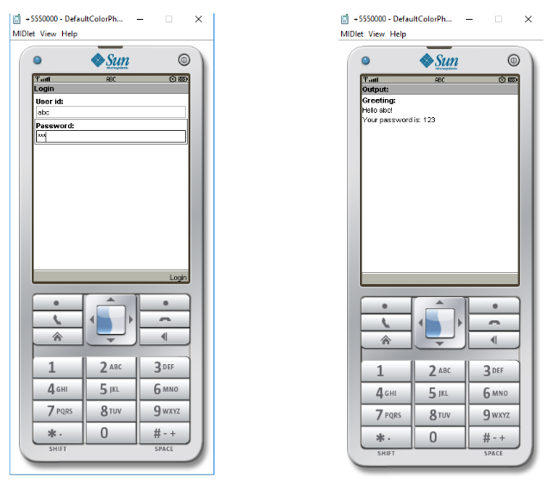

Conclusion

From the above experiment we learnt about the basics of J2ME frameworks, what are

the different types of layouts and when to use them. We also designed a basic app that

uses GUI components.